ΕΛΛΗΝΙΚΗ ΔΗΜΟΚΡΑΤΙΑ
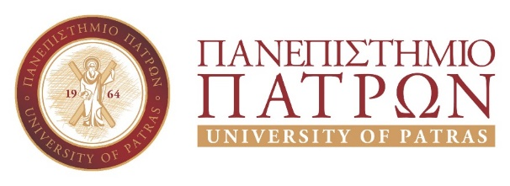 |  | 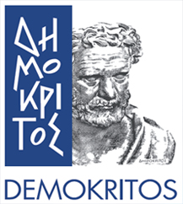
SCHOOL OF NATURAL SCIENCES
DEPARTMENT OF CHEMISTRY
SECRETARIAT
Ms Priovolou Spiridoula
Phone.: (30)2610997101,
E-mail: spriovol@upatras.gr

Patras 2/6/2021
No: 1011/6203/17673

The Department of Chemistry, University of Patras, Greece,
and
the Institute of Biosciences and Applications, NCSR “Demokritos”, Agia Paraskevi, Athens, Greece,

announce the Joint Post-Graduate Programme (JPGP) in “Applied Biochemistry: Clinical Chemistry, Biotechnology, Evaluation of Pharmaceutical Products”
for twenty (20) post-graduate students for the academic year 2021-2022.

The Inter-Institutional Committee of JPGP (meeting 11/23-April-2021) and according to the Rectorate Decision 1364/20835 (FEK 2969/24-7-2018) concerning the establishment of JPGP, decided to announce twenty (20) vacant posts for postgraduate students, within the framework of the Joint Postgraduate Studies Programme for the academic year 2021-2022, in the:

Applied Biochemistry: Clinical Chemistry, Biotechnology, Evaluation of Pharmaceutical Products

The JPGP accepts graduates of Schools of Natural Sciences, Health Sciences, Geotechnical Sciences and Agronomic Sciences, of Technical Universities, and of relevant Departments of Open Universities. Applications may also be submitted by undergraduate students of the above listed Schools and Departments, provided that they have presented a Certificate of Completion of their studies no later than one day before the Inter-Institutional meeting date of the JPGP to validate the list of selected candidates. In this case, the diploma is submitted before the start date of the programme. In any case, the selected candidates will have to provide all the necessary supporting documents until the end of the entries.
The selection is based on the following criteria: the final grade of the bachelor or diploma degree of the candidate, the grades in undergraduate courses relative to the subject of JPGP, the grade in diploma thesis where this is envisaged in undergraduate level, and the potential research or professional activity of the candidate.

In particular, account shall be taken of:
i. The general grade of the degree.
ii. The grades in three undergraduate courses, relative to the subject of JPGP, such as Biochemistry, Biology, Biotechnology, Clinical Chemistry, Pharmacology, Bioinformation, Biophysics, among others.
In case candidates have not been taught three courses whose content is relevant to that of courses described above, the selection committee will determine the ones to be examined in order to complete their assessment.
iii. The grade in experimental diploma thesis, where this is envisaged in undergraduate level, with an assessment commensurate with its duration. The basis is 20 points for an one-year duration of an experimental thesis.
iv. Good knowledge of English language, at least in a basic level (First certificate in English). If a candidate does not hold an English language degree, he/she will be examined by the selection committee for his/her English Biochemical Skills.
v. Interview with the candidate, including: (i) assessing his/her personality; (ii) assessing his/her possible research activity; (iii) assessing the quality of the required two recommendation letters.

During their courses, the candidates are required to attend courses and successfully examined, present seminars and participate in laboratory education of undergraduate students.
The teaching of the courses takes place in the classrooms of the Department of Chemistry, and in some cases, such as seminars and lectures of invited researchers, in the teaching rooms of the NCSR "Demokritos" as defined in the timetable. There is also the ability to distance learning.
The JPGP provides for the running of study fees, the amount of which is set at €1,500. Payment of the tuition fees is made in three equal installments, the first with the registration of each postgraduate student and the next with each renewal of the registration.

Candidate postgraduate students will be required to submit the application in capital letters and the supporting documents required electronically via the portal https://matrix.upatras.gr/sap/bc/webdynpro/sap/zups_pg_adm# from the date of publication of the proclamation up to September 22, 2021

Required documents:
- Certificate of all grades during undergraduate courses.
- Curriculum vitae.
- Photocopy of identity card.
- Copy of degree. If the qualifications are from a non-European University, the relevant attestation of equivalence by the Hellenic National Academic Recognition Information Center (NARIC) is also required.
- Scientific publications.
- Proof of foreign language.
- Two recommendation letters (will be submitted to the Secretariat of the Department of Chemistry, University of Patras).
- Computer use certificate.

Candidates will also have to submit a paper copy of the above documents to the Secretariat of the Department of Chemistry, University of Patras.
It is also announced that the candidates interview by the Selection Committee will take place at September 27, 2021, 10.00 am, in the Conference Hall of the Department of Chemistry, University of Patras (Northern Building, ground floor). There is always the possibility of online interviewing. A ZOOM link will be available.
The examinations will take place between October 6 to 8, in the classrooms of the Department of Chemistry, University of Patras, according to the programme announced by the selection committee.

More information can be obtained by the Secretariat of the Department of Chemistry, tel. 30-2610-997101 email: chemsecr@upatras.gr, chemsecrpost@upatras.gr
URL: http://www.chem.upatras.gr

The Director of JPGP

Professor Demitrios Vynios

